**GRAY & SONS (CHELMSFORD) LIMITED  
Rignals Lane, Galleywood, Chelmsford, Essex, CM2 8RE**

**Telephone: (01245) 475181**

[**www.grayandsons.co.uk**](http://www.grayandsons.co.uk)[**enquiries@grayandsons.co.uk**](mailto:enquiries@grayandsons.co.uk)

**To Let on a new 6 Year Tenancy**

**The Orange Tree, Chelmsford**

**Lower Anchor Street, Chelmsford CM2 0AS**

***A fantastic business opportunity awaits…***

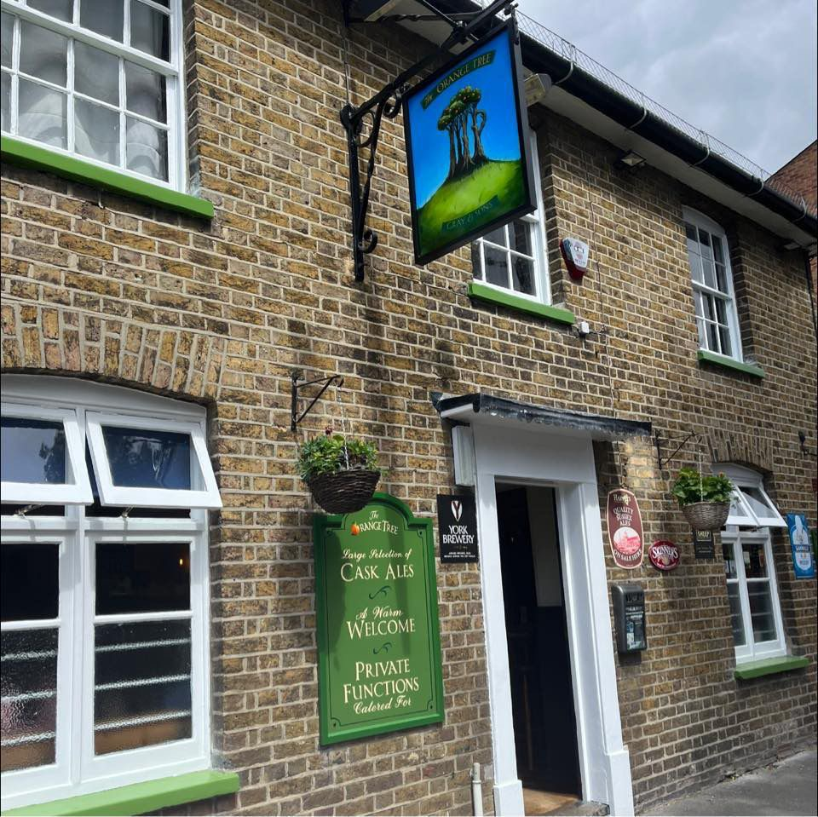

**Location**

The Orange Tree is located on Lower Anchor Street in Chelmsford, a stone’s throw from Essex Cricket ground and a short walk from the city centre. It is a two-bar operation with a unique well designed back garden space.

The entire property, including the domestic accommodation, is in excellent decorative condition.

There is a small car park for 6 cars to the rear and side, along with external shed storage.

**The Property**

This two-bar operation is naturally split into two sides for differing social occasions, with creatively designed bespoke furniture to maximise the cover number in both spaces. There is comfortable seating for 70 inside and 65 outside.

Customer toilets are accessed to the rear of the bar area before exiting to the rear beer garden space. To the rear left of the building is a small commercial kitchen for both the tenants’ own use and to prepare and deliver a unique local food offering.

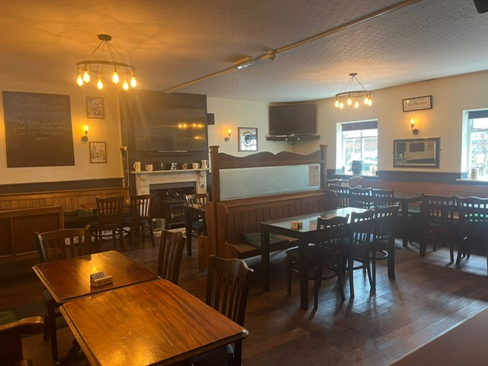

**Bar Servery and Trading Areas**

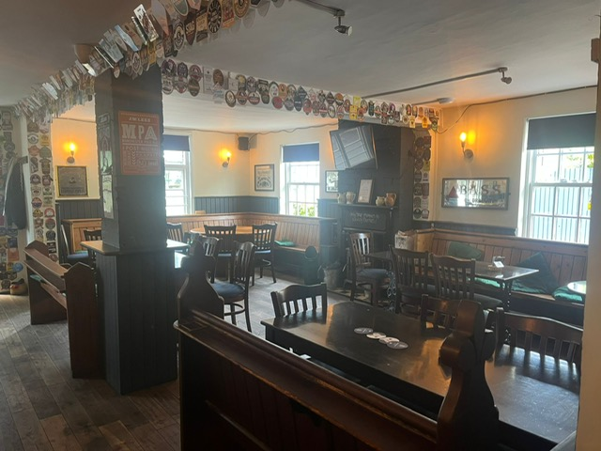

The first floor private accommodation comprises of two double bedrooms, an office, a lounge and a bathroom.

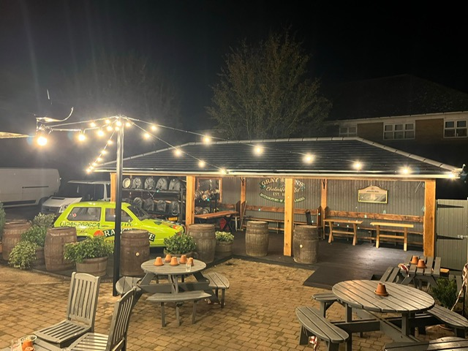

**Rear Beer Garden**

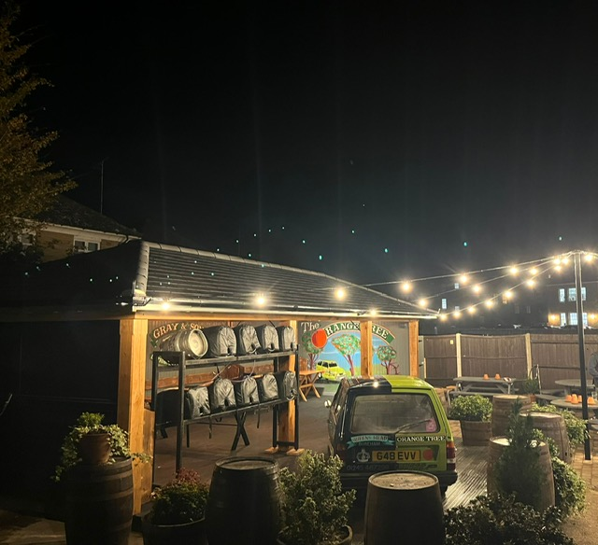

**Trade**

The trade comprises of live TV sports and multiple events including quiz nights and live music. There are particularly high footfall days & evenings when Chelmsford cricket teams play live on their adjacent New Writtle St cricket ground.

**Our Agreement**

The Tenancy is for 6 years and is on a rolling basis. You must buy all beer from Gray & Sons, and you are free of tie for all cider, wines, spirits and minerals.

As well as supplying the main national beer brands, we are proud to support local breweries which in turn ensures that a Gray & Sons pub can provide a varied and unique offer.

While we no longer brew our own beers, we still uphold the values of the traditional brewery tenancy and enjoy a close relationship with our tenants.

A summary of each of our responsibilities can be found [*here*](https://c2273206-a9c4-4344-b982-d9c01fd7762c.usrfiles.com/ugd/c22732_4506edd9793145a9864a09ed6f84631b.pdf)

**Rent**

The rent is **£28,000** per annum plus vat which is reviewed every three years, unless we agree to make any major improvements to the property which would trigger an interim rent review.

We do not link our rents to inflation, so once the rent is set it won’t change until the next review.

The rent is due monthly and apart from beer invoices, there are no other charges from us.

**Rateable Value**

The current rateable value for business rates calculations listed on the Government website is £18,750.

**Volume history**

We don’t get to see Tenant’s accounts, but we do know how much beer we have delivered.

Total Beer (in Brewer’s Barrels Brls, 1 Barrel being 36 Gallons)

2019 - 330 Brls

2020 - 155 Brls (Covid Restrictions significantly reducing trade)

2021 - 231 Brls (Covid Restrictions significantly reducing trade)

2022 - 266 Brls

2023 - 273 Brls

2024 - 252 Brls

Any AWP machine income will be shared equally between the tenant, the supplier and Gray & Sons.

We do not take a share of pool tables, juke boxes and other ancillary equipment.

**Estimate of Ingoing Costs**

We have estimated the ingoing costs to be around £30,000, the majority of which will be the cost of the remaining tenant’s inventory and stock, along with a security deposit of £4,000.

Above this, you will also need sufficient working capital to execute your business plan.

**Next steps**

We encourage all serious applicants to visit the site as a customer and kindly ask that you are discreet with existing staff whilst doing so.

Should your application progress further, we will arrange a full viewing for you.

To apply, please submit an Application Form, which can be downloaded [*here*](https://c2273206-a9c4-4344-b982-d9c01fd7762c.usrfiles.com/ugd/c22732_dd3724ae3cca466f99a0a941d84841be.pdf).

We will also need to see a business plan detailing your ideas for the pub.

Prior to interview, we will require you to hold a Personal License and have completed the B.I.I PEAT (Pre-Entry Awareness Training) Course – this is readily available online and gives you a great insight into what a typical tenancy involves.

**Any Questions?**

If there is anything else you would like to know at this stage, feel free to call Gray & Sons on 01245 475181 and ask for Andrew Smurthwaite.