GRAY & SONS (CHELMSFORD) LIMITED
Rignals Lane, Galleywood, Chelmsford, Essex, CM2 8RE
Telephone: (01245) 475181
www.grayandsons.co.uk enquiries@grayandsons.co.uk

To Let on a new 6 Year Tenancy
THE COACH & HORSES
Chapel Street, Billericay, Essex CM12 9LU

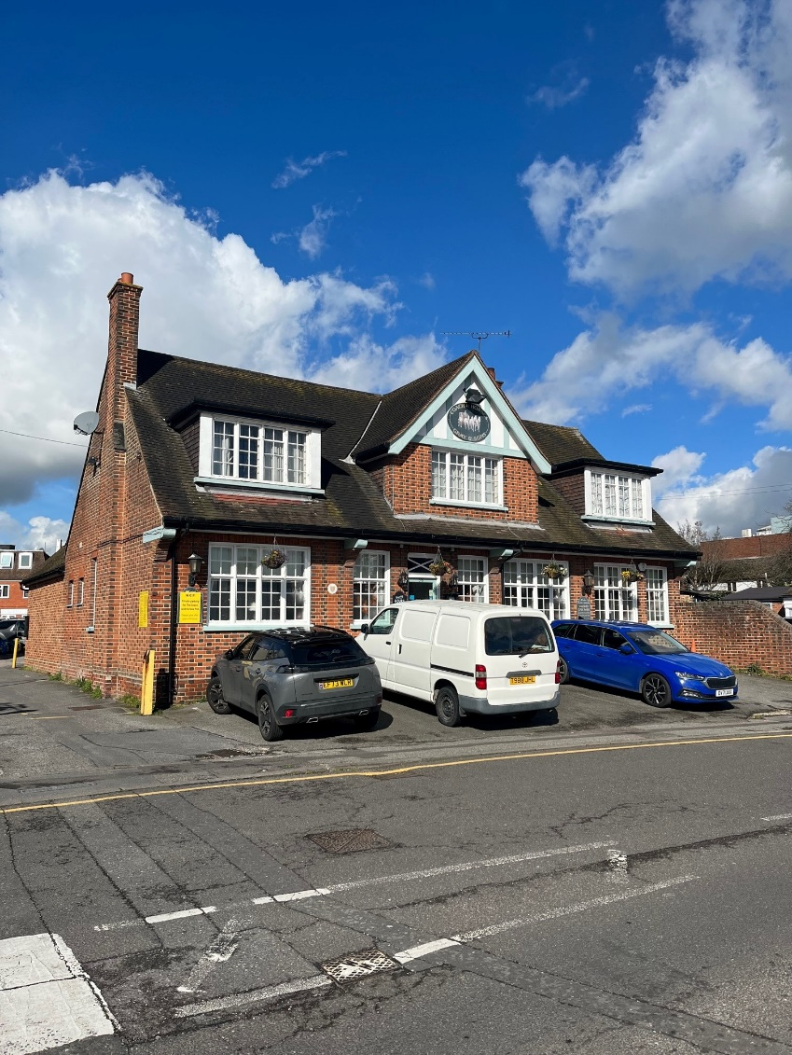

Location
The Coach & Horses is located centrally within the town centre, located on one of the through routes immediately behind the busy High Street.
The town itself comprises a selection of quality shops, pubs and restaurants and enjoys excellent transport links with surrounding towns, with Billericay station less than 10 minutes’ walk away.

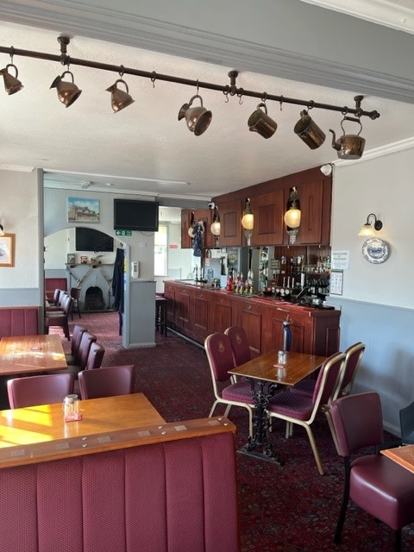

The Property
The front door leads directly into the large open plan bar, laid out with a mixture of loose and fitted seating. To the side of the single servery, a corridor leads to the toilets and an enclosed rear courtyard beer garden.
A well-equipped trade kitchen is located at the other end of the pub, along with a utility/store room and access to the basement beer cellar and the first floor domestic accommodation.
The 2 bedroomed private accommodation comprises Bedroom 1 (currently laid out as office, Bathroom/toilet, Domestic kitchen, Lounge and Master Bedroom.

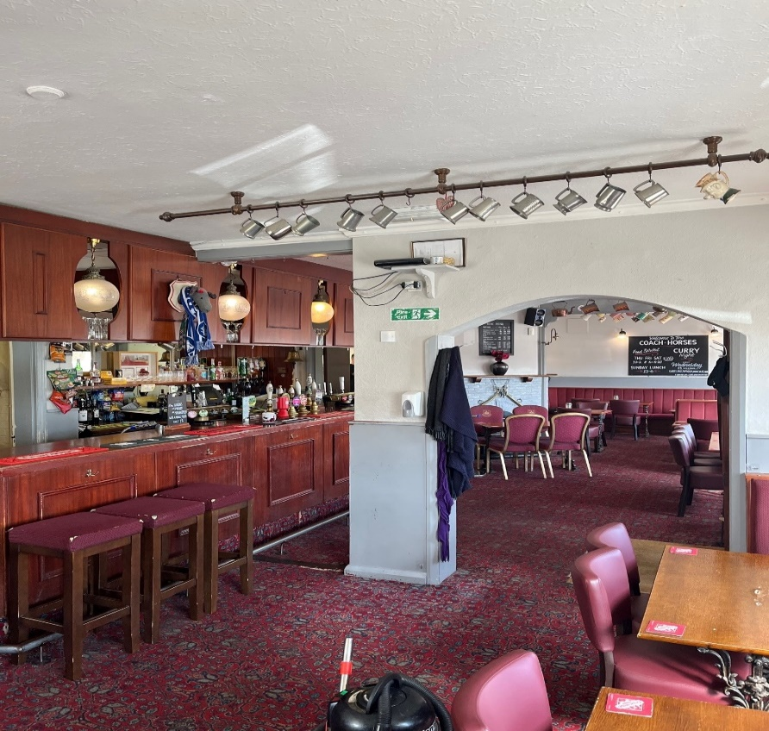
Main Bar Interior
To the front and side of the property there are 12 parking spaces for customers – this area is currently patrolled and managed by NCP under contract with our current tenant. There is a large public car park nearby in the High Street.

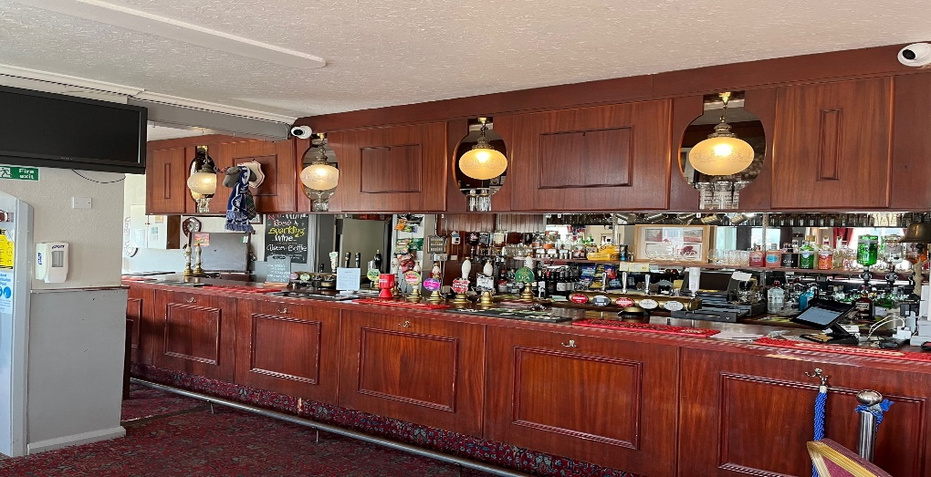

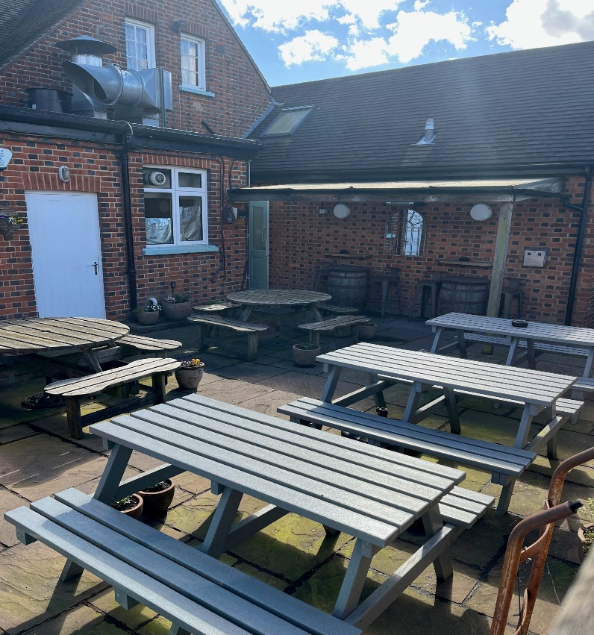
Patio Beer Garden

Trading Style
The Coach and Horses is a successful community based wet led pub which, along with a home-cooked style menu, has gained a reputation for serving an interesting mix of beers and ciders, including regularly rotating cask beers from around the country.
Having been in the same hands for 14 years, we are seeking operators who will aim to continue in this style.

Our Agreement
The Tenancy is for 6 years and is on a rolling basis. You must buy all beers and lagers from us but you are free of tie for ciders, wines, spirits and minerals.
As well as most of the main national brands we are proud to support local breweries which in turn ensure that a Gray & Sons pub feels like a freehouse – something which we know is important to you and your customers.
While we no longer brew our own beers, we still uphold the values of the traditional brewery tenancy and enjoy a close relationship with our tenants.

A summary of each of our responsibilities can be found here

Rent
The rent is £24,000 per annum plus vat which is reviewed every three years.
We don’t link the rent to inflation, so once the rent is set it won’t change for three years.
The only exception would be if we invest in any major improvements to the premises.
The rent is due monthly and apart from beer invoices, there are no other charges from us.

Some Numbers to give you a flavour.
We don’t get to see Tenant’s accounts, but we do know how much beer we have delivered.
Beers and Lagers (in Brewer’s Barrels Bbl, 1 Barrel being 36 Gallons)
2019 – 215 Bbl
2020 – 113 Bbl (Covid Restrictions)
2021 – 135 Bbl (Covid Restrictions)
2022 – 191 Bbl
2023 – 195 Bbl
Current 12-month total 200 Bbl as at 31st March 2024.

Rateable Value
The current rateable value for business rates calculations listed on the Government website is £19,000.

Estimate of Ingoing Costs
We anticipate the incoming tenant having funding of circa £30k to cover the purchase of the stock and inventory as well as the Security Deposit of £4,000.
Above this, you will also need sufficient working capital to continue the business.

Next steps
If you want to have a look, we ask that you visit discreetly as a customer at this stage.
To apply, please submit an Application Form, which can be downloaded here. We would also like to see a brief business plan detailing your ideas for the pub.
Should your application progress further, we will arrange a full viewing for you.
Finally, we will require you to hold a Personal License and have completed the B.I.I PEAT (Pre-Entry Awareness Training) Course – this is easily available online and gives you a good insight into what a typical tenancy involves.

Any Questions ?
If there is anything else you would like to know at this stage, feel free to call us on 01245 475181 and ask for Colin Summers.

