GRAY & SONS (CHELMSFORD) LIMITED
Rignals Lane, Galleywood, Chelmsford, Essex, CM2 8RE
Telephone: (01245) 475181
www.grayandsons.co.uk enquiries@grayandsons.co.uk

To Let on a new 6 Year Tenancy
THE VICTORY INN
The Green, Wickham St Paul, Halstead CO9 2PT

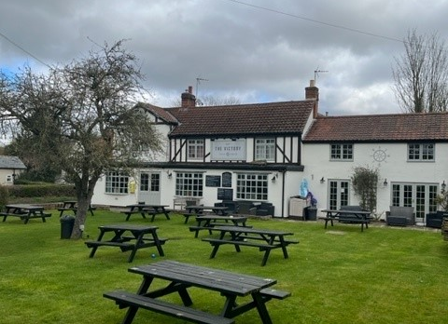

Location
The Victory is positioned prominently in the centre of the desirable village of Wickham St Paul, signposted from the A131 Halstead to Sudbury road and easily accessible from nearby Sudbury, Halstead, Castle Hedingham and Sible Hedingham.

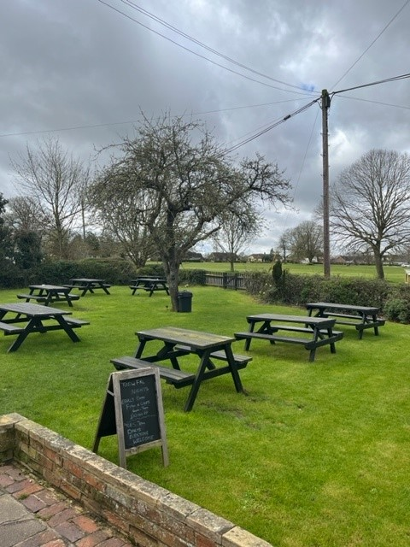
Beer Garden facing Village Green

The Property
The Ground Floor comprises Main Bar with single servery laid out for 34 diners, a Public Bar with TV, Pool Table and Darts and a separate Restaurant area containing a further 34 covers.
A well-equipped trade kitchen is located behind the restaurant along with a utility/storeroom and cooled Beer Cellar.
The private accommodation comprises 3 Bedrooms, Lounge, Shower/Toilet and Domestic Kitchen.

There is a further self-contained flat with its own access, comprising 3 Bedrooms, Lounge, Kitchen, and Bathroom/Toilet which can be sub-let by the pub tenant as an additional income stream.

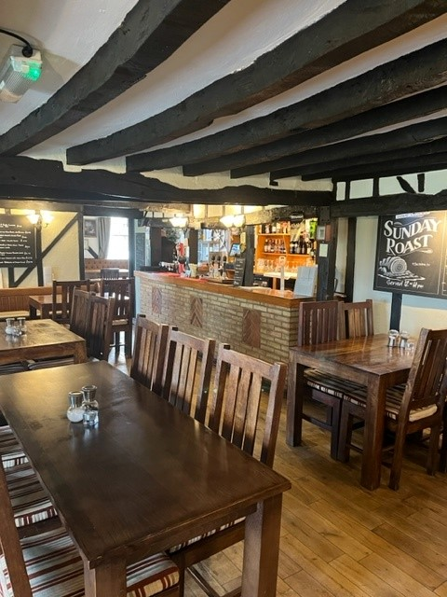
Main Bar with Servery

Externally, there is a large Beer Garden to the front of the property laid out with benches, and car parking is available along the side and at the rear of the pub.

An additional large enclosed private garden is located at the rear of the building for tenant’s use only, which also houses the LPG and Oil Tanks for the pub.

Trading Style
The Victory has a well-deserved reputation as a quality, family friendly Destination Food pub.
Having been in the same hands for the last 14 years or so, we are seeking operators who will aim to continue in this style, whilst putting their own individual stamp on the trade.

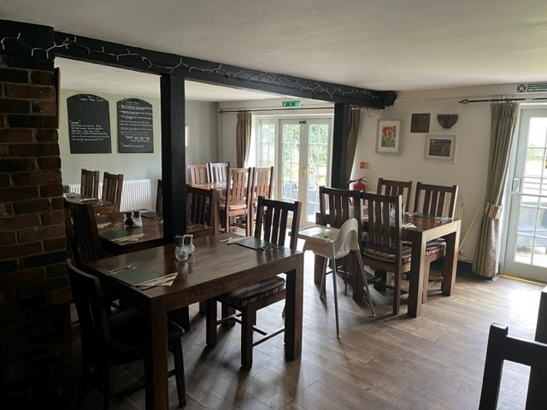
Restaurant Area facing Beer Garden

Our Agreement
The Tenancy is for 6 years and is on a rolling basis. You must buy all beers and lagers from us, but you are free of tie for ciders, wines, spirits and minerals.
As well as supplying most of the main national brands, we are proud to support local breweries, which in turn ensures that a Gray & Sons pub feels like a freehouse – something which we know is important to you and your customers.
While we no longer brew our own beers, we still uphold the values of the traditional brewery tenancy and enjoy a close relationship with our tenants.

A summary of each of our responsibilities can be found here

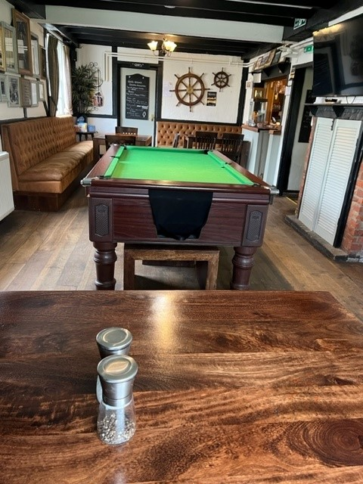
Public Bar

Rent
The rent is £25,000 per annum plus vat including the self-contained flat and is reviewed every three years.
We don’t link the rent to inflation, so once the rent is set it won’t change for three years.
The only exception would be if we invest in any major improvements to the premises.
The rent is due monthly and apart from beer invoices, there are no other charges from us.

Some Numbers to give you a flavour.
We don’t get to see Tenant’s accounts, but we do know how much beer we have delivered.
Beers and Lagers (in Brewer’s Barrels Bbl, 1 Barrel being 36 Gallons)
2019 – 81 Bbl
2020 – 41 Bbl (Covid Restrictions)
2021 – 60 Bbl (Covid Restrictions)
2022 – 59 Bbl
2023 – 68 Bbl
Current 12-month total 66 Bbl as at 31st March 2024.

Rateable Value
The current rateable value for business rates calculations listed on the Government website is £11,250.

Estimate of Ingoing Costs
We anticipate the incoming tenant having funding of circa £35k to cover the purchase of the stock and inventory as well as the Security Deposit of £4,000.
Above this, you will also need sufficient working capital to continue the business.

Next steps
If you want to have a look, we ask that you visit discreetly as a customer at this stage.
To apply for the tenancy, please submit an Application Form, which can be downloaded here.
We would also like to see a brief business plan detailing your ideas for the pub.
Should your application progress further, we will arrange a full viewing for you.

Finally, we will require you to hold a Personal License and have completed the B.I.I PEAT (Pre-Entry Awareness Training) Course – this is easily available online and gives you a good insight into what a typical tenancy involves.

Any Questions ?
If there is anything else you would like to know at this stage, feel free to call us on 01245 475181 and ask for Colin Summers.

